**User Manual**

**Keyboard Generator**



**INDEX**

**1. Run the program**

**2. Description of views**

2.1. Start Session

2.2. Create User

2.3. Main Page

2.4. Create Keyboard

2.5. Display Keyboards

2.6. Modify Keyboard

2.7. Profile

2.8. Change User

**3. Confirmation/error messages**

# Run the program

To run the program you will first need to unzip the zip. Then open the terminal and execute the following:

To run the program with the auto.sh file (compile and run at the same time) we have to run the command ./auto.sh, in case it doesn't work, we have to give permissions and it could be used.

We run the chmod +x auto.sh command, go to the /FONTS directory and run chmod +x make.sh, to give permissions to the make.sh file, and run it with ./make.sh. Finally, access the EXE directory (execute cd ../EXE from the SOURCES directory) and give permissions with chmod +x Main.sh. Now we can run the program, we have given permission to all the .sh files we have, so we can run the ./Main.sh command to see our application. The auto.sh file also works if we want to run it, access the main directory (cd .. if we are in EXE) and run ./auto.sh.

To test the application, there is an account already created where the user is "Teclados" and the password is "123". This account already has different keyboards created from different alphabets, we created it to have a keyboard with every alphabet and layout on hand.

# Description of the views

## Log in

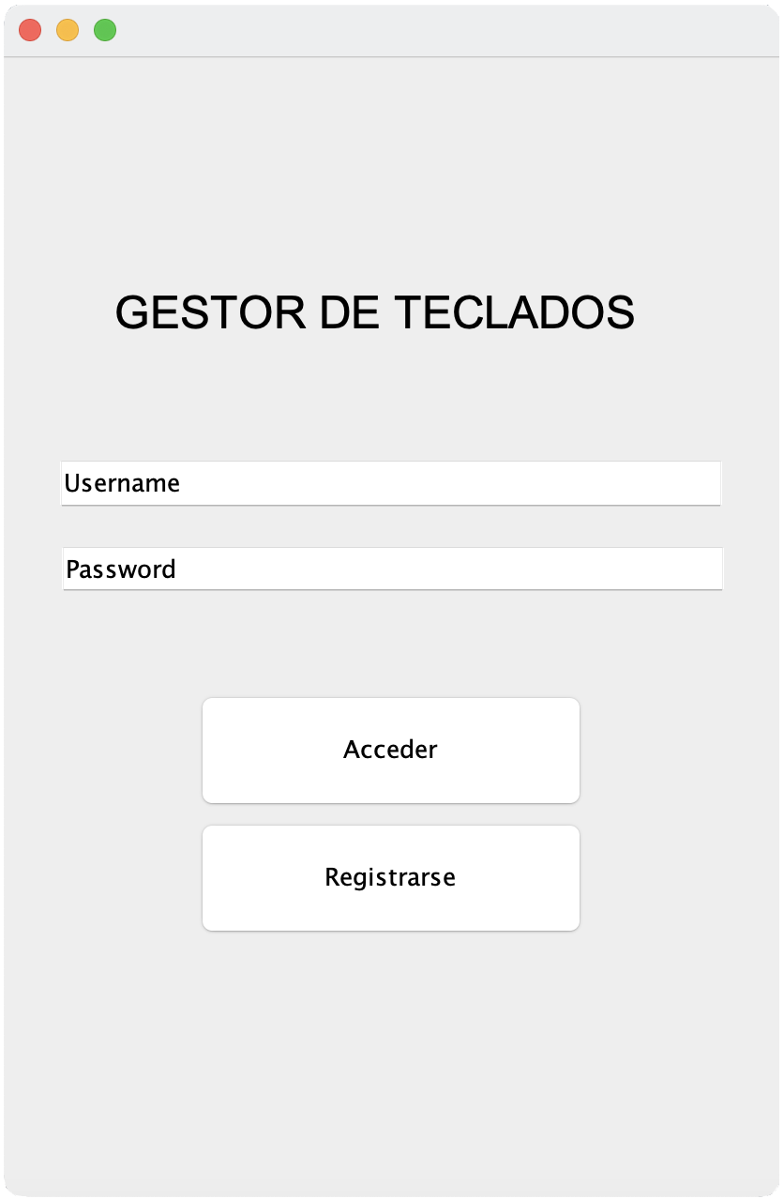

*Figure 1: Initial screen*

This screen is the entrance to the system, allowing users to log in or register if it's their first visit or they want to create a new account. It presents two fields to enter the credentials: one for the username and the other for the password. The username text field starts with the text "Username", and the password field is initially displayed with the text "Password", but these clear the default content when selected.

The "Sign in" button allows users to log in with the credentials entered, while the "Register" button redirects the user to the account creation screen to register if they do not already have an account created.

## Create User

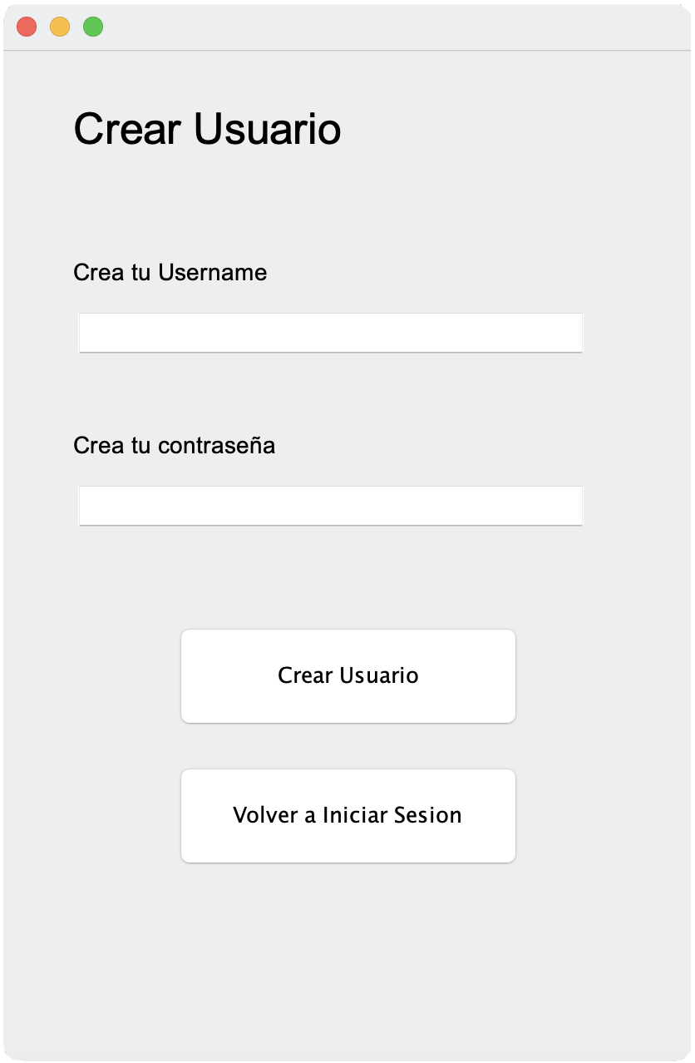

*Figure 2: Change user screen*

This screen gives the user the ability to create a new user account. In this interface, fields are provided to enter a new username and password.

The username text field allows the user to enter the desired name for their account. By selecting this field, the "Username" text disappears to allow the name to be entered. On the other hand, the password field allows the user to enter a password. Selecting this field initially displays the text "Password" until the user starts typing.

The "Create User" button is used to start the process of creating the new account with the entered username and password. On the other hand, the "Log In Again" button redirects the user to the login screen in case they want to abandon the process of creating the new account.

## Main Page

*Figure 3: Main screen Figure 4: Dropdown to clear the keyboar*

This is the main screen of the program. On this screen, the user can perform a wide variety of functions.In the center of the screen is shown the list of the user's keyboards. If you don't have one created, this list will be empty. To create a new keyboard, the user must press the "New Keyboard" button. Pressing it will redirect you to the keyboard creation screen. After the creation is complete, you will be returned to the main screen and the new keyboard will appear in the list.

To access one of the keyboards, the user must click on the name of the keyboard they wish to view. Doing so will redirect you to the "Keyboard View" screen.

In this screen, the user also has the functionality to delete a keyboard. To do this, you must select the keyboard you want to delete in the drop-down menu next to "Delete keyboard", as shown in figure 4. Once the keyboard is selected, you must press the "Delete" button, and then a confirmation message. In addition, if the user wants to access their profile, they can do so by clicking on the "Profile" button located at the bottom right. This will take you to the “Profile” screen.

## Create Keyboard

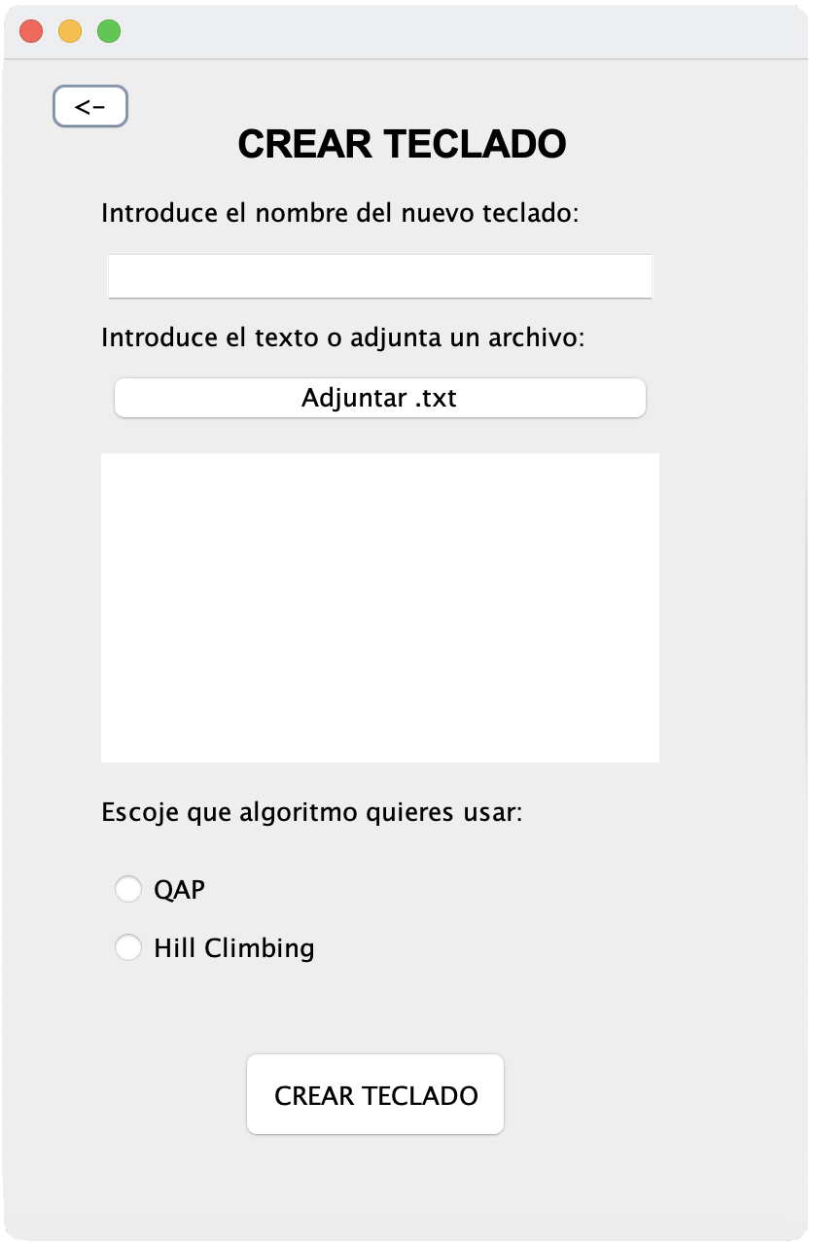

*Figure 5: Create keyboard screen*

The main functionality of this screen is the creation of a keyboard based on the parameters entered by the user.

To begin, the user must enter the name of the keyboard they want to create. You then have the option to attach a .txt document or type it into the text area. If you choose to attach it, you will have to press the "Attach .txt" button. Once this is done, the user will be able to navigate until they find the document they wish to attach.

The document attached or written in the text area can be written in two different formats: text form or word frequency. If word frequencies are used, they must be written following the following format: word frequency, word frequency… and so on.

Finally, the user must choose which algorithm to use to generate the keyboard: QAP or Hill Climbing. Once all the fields have been entered, pressing the “Create Keyboard” button will create the keyboard and the user will be redirected to the main screen, where the new keyboard will appear in the list. If at any time the user wants to return to the main screen without creating a keyboard, he must press the “<-” button located in the upper left corner.

## View Keyboards

*Figure 6 and 7: Views of the keyboards*

This screen gives the user the ability to view the keyboard they have previously chosen in the main view. The user can perform various functions on this screen. To test the keyboard you can press the keys and see what you type in the text area just above it. To erase what you have written, just click the Clear button.

If you want to change the distribution of the keys, you must press the 2 keys and see which are the ones labeled Key 1 and Key 2, since these labels indicate which are the last 2 keys pressed by the user. And press the Swap button to exchange the position between the 2 keys.

If the user wants to save the changes made to the keyboard layout, he must press the Save button, so the next time he wants to view this keyboard, it will open with the saved layout.

In addition, if the user wants to modify the name of the keyboard or his document, he must press the Edit Keyboard button and he will be redirected to the view that allows these modifications to be made. Finally, in case the user wants to go back to the previous view, just

you must click the <- button and it will return to the main view.

## Modify Keyboard

*Figure 8: Screen to modify the keyboard*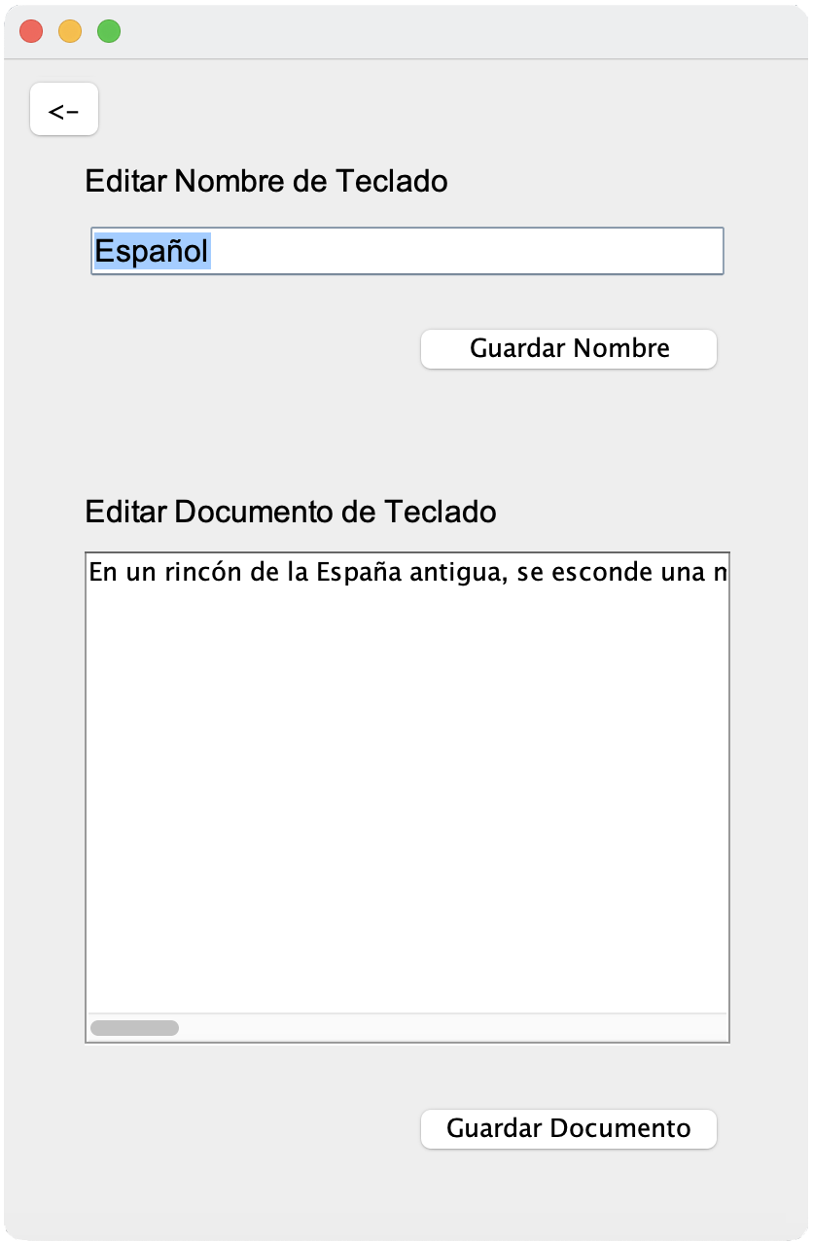

This screen offers the user the possibility to modify the name and document of the keyboard. To be able to change the name of the keyboard, you just have to enter the name you want to use and press the Save Number button. If the modification was successful, other than a duplicate name, a message indicating that the change was made will appear. Otherwise an error message will appear.

If the user wants to modify the keyboard document, he can edit the document that belongs to the keyboard, and enter the new one he wants to use. To save the changes the user must click the Save Document button, this will save the document and recalculate the keyboard.

Finally, in case the user wants to return to the previous view, he only has to click the <- button and he will return to the keyboard display view, where he would see the keyboard already updated if any modification has been made.

## Profile

*Figure 9: Profile screen*

This screen represents the user's profile in the program. In it, the user has the ability to manage various functions related to managing their profile. At the top, the current username is displayed, which can be modified. To change the username, you can enter a new name in the text field and press the "Save Number" button.

The "Change User" button allows the user to make changes related to system users. Pressing it redirects you to another screen to manage these options.

To close the current session and exit, the user has the "Logout" button. Pressing it logs you out and redirects you to the login screen, confirming your exit with an informational message. Also, to permanently delete the account, there is a "Delete Account" button. Once the button is clicked, a confirmation is displayed to ensure the user's intention to delete the account. If confirmed, the account is deleted and redirected to the login screen, confirming the deletion with an informational message.

## Change User

*Figure 10 and 11: User change screens*

This screen allows the user to select another system user to change the current session to in a simple and secure way, as it has an authentication method. In the center of the interface is displayed a list with the names of available users, that is, registered users.

The user can click on a user name from the list and press the "Select User" button. You are then prompted to enter the password for the selected user.

Once the password is entered, if it matches the password of the selected user, the session is switched to that user and a confirmation message is displayed, while it will display an error message if the password is incorrect. Additionally, there is a "Back" button that allows you to return to the current user's profile screen, canceling the switch user selection if used.

# Confirmation/error messages

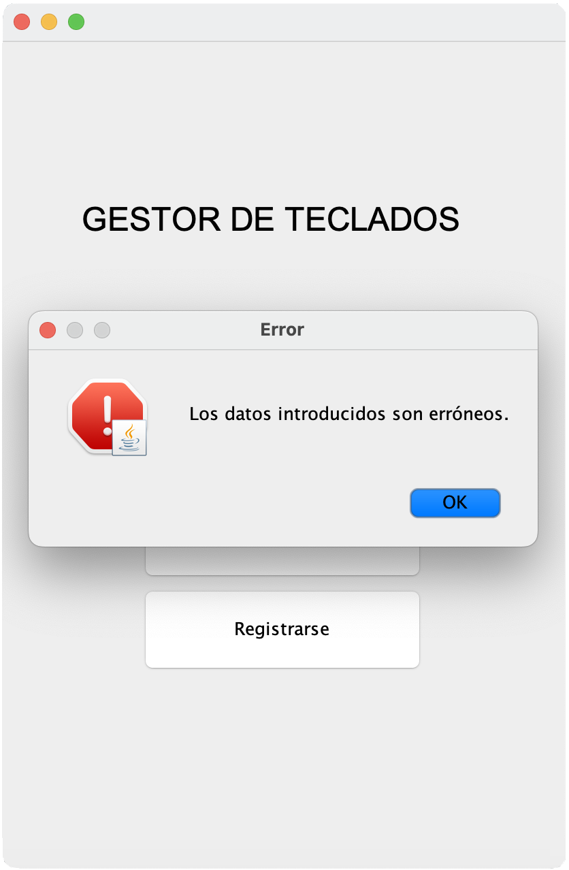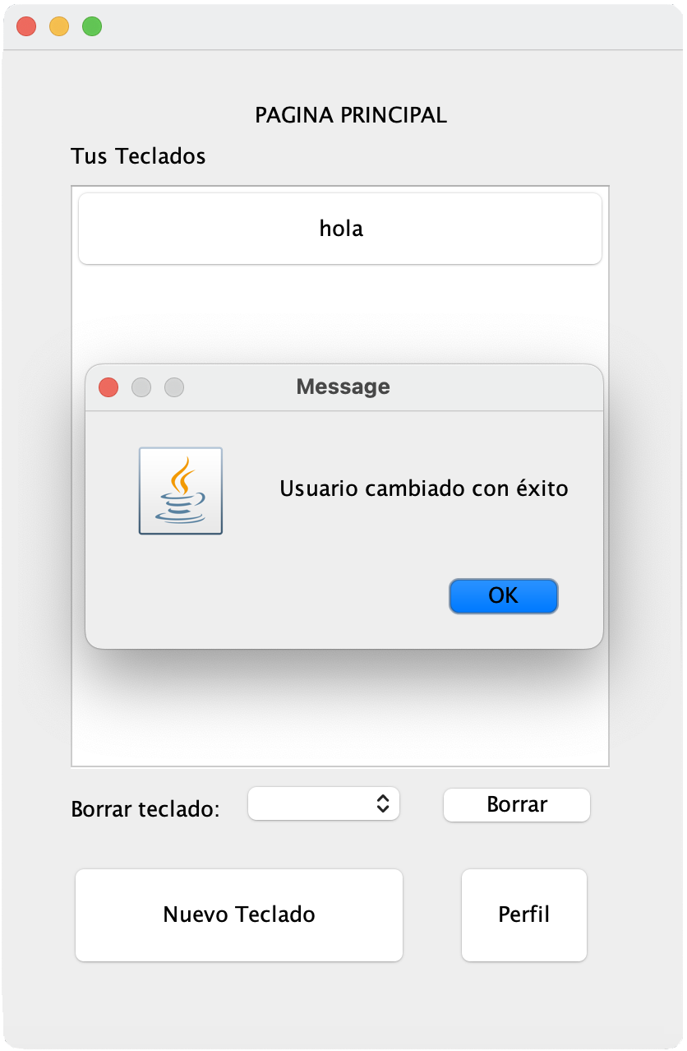

*Figure 12 and 13: Confirmation and error messages*

Messages are a part of communication with the user, as they help provide a clearer user experience and guide the user through various interactions within the application, informing about the results of the actions taken.

The confirmation message is used when an important action is successfully performed, such as successfully switching users. On the other hand, error messages are used when there is a problem or when an action cannot be performed correctly. These messages tell the user that an error has occurred and include specific details about the problem.

In figures 12 and 13 we have provided some examples, although when interacting with the project, many others appear.